**Onboarding Prerequisites**

To ensure a smooth onboarding in the current situation kindly upload the responses for all the below points in the **File Section** under **Business Continuity Inputs** before your date of joining

1. **Internet Speeds:** 40 Mbps Broadband (Primary), 8 Mbps (Secondary) Or Internet Dongle/Mobile Hotspot with 4G. Please share the avg speed of three speed test in [fast.com](https://protect-us.mimecast.com/s/fxALC68yZvcrPJjoSpMjCP).  (click on the more options of the speed result and attach the screenshot here as shown below.)

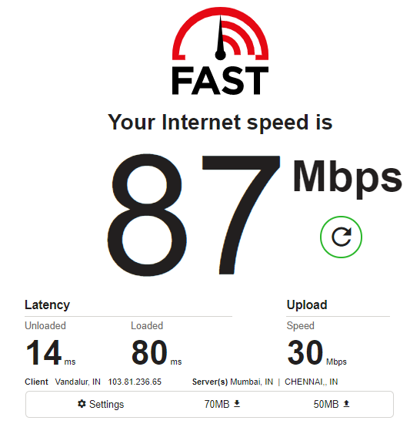

1. **Address from where you will be working during the next few weeks?**

SFNo:54/2B, Plot no:3, Vasanthapuram Extn 1, Unamancheri, Kolapakkam, Chennai – 600048.